DETAILS FOR
The ChemSex Monologues performances in Berlin

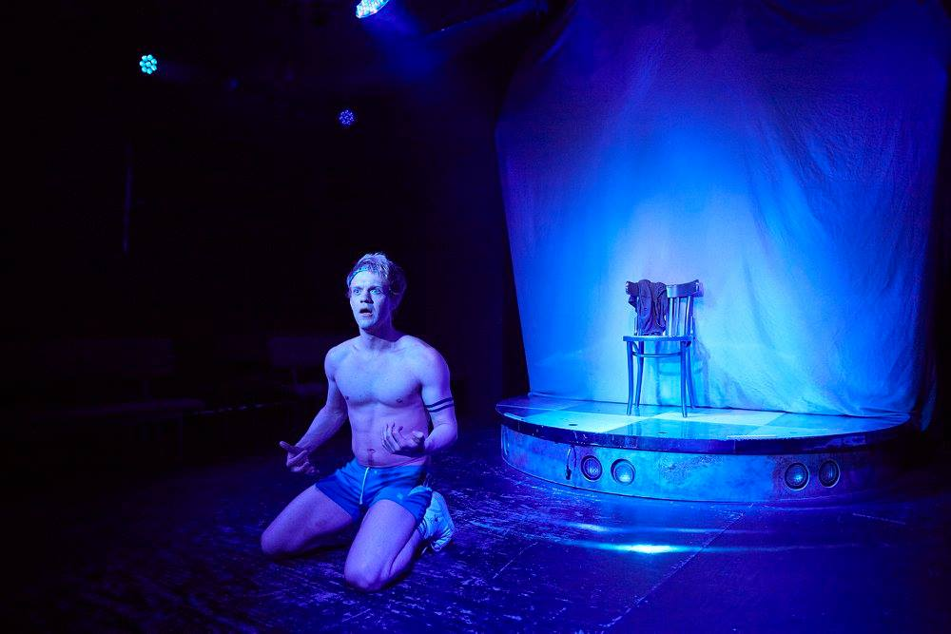

About:
A nameless narrator meets a sexy boy on a Vauxhall night out, who introduces him to G’s pleasures; a club night poster boy gets taken to Old Mother Meth’s place by a porn star; Fag Hag Cath is finding the chillouts have become more about the sex; Daniel is a sexual health worker who does community outreach in the saunas; and the nameless narrator meets up with his sexy boy again. Explicit, funny and touching, The ChemSex Monologues displays a realm that is sometimes dark but populated by very real, loveable people.

Details:
- Flyer: www.profbriefings.co.uk/chemsex2018/index.html
- wilde Oscar Theatre, Niebuhrstraße 59/60, 10629 Berlin (wildeoscar.de)
- Friday and Saturday, 23 and 24 March, 19.00
Followed by open discussion in German, Russian & English
- Sunday, 25 March, 15.00
Followed by a writer’s workshop in German, Russian & English
- Tickets: 10€ / 5€ (students)
Email nd@ihp.hiv to reserve tickets. Pay at the door.
Extra donations to support the European ChemSex Forum welcomed

- Performance is in English
- Written by Patrick Cash (www.patrickcash.co.uk)
- Directed by Luke Davies (www.luke-davies.info)
- In conjunction with the 2nd European ChemSex Forum (www.profbriefings.co.uk/chemsex2018/index.html)

Sponsored by Friends of the European ChemSex Forum
Thank you to wilde Oscar and Schwulenberatung for their support

